PPT
1. Introduction & Objectives
- Determine the overall distribution of positive, negative, and neutral sentiments.
- Compare average sentiment scores across different camera brands.
- Identify the most frequent and impactful keywords within the reviews.
- Generate supplementary engagement metrics to gauge user advocacy and community interaction.
2. Methodology
The analysis employed a classification model (e.g., a machine learning classifier such as BERT or a similar NLP model) trained to categorize text into sentiment labels: Positive, Negative, and Neutral. Additionally, Term Frequency-Inverse Document Frequency (TF-IDF) was calculated to evaluate the importance of keywords within the review corpus, distinguishing between their prominence in positive versus negative contexts. The metrics for Referral Score, Community Score, and Discussion Score were derived from user engagement patterns within the dataset or conversation logs.
3. Results
3.1 Brand-wise Sentiment Comparison
The sentiment classification model shows a dominant positive bias in the review dataset.The average sentiment scores for major camera brands (Canon, Fuji, Nikon, Sony) were calculated. All brands exhibit a very strong positive sentiment score, with neutral scores being significantly lower and negative scores being minimal. The variation between brands is slight, suggesting that overall customer satisfaction is consistently high across the market leaders analyzed.
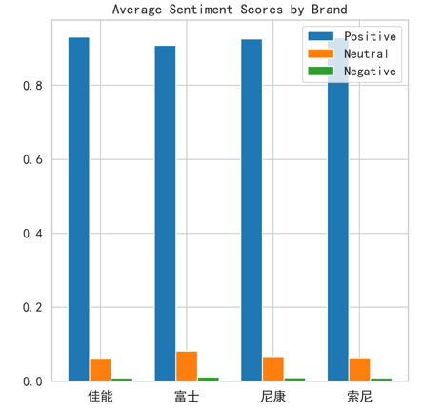
3.2 Keyword Analysis
Importance (TF-IDF):The keyword "相机" also has the highest average TF-IDF score (0.1391), establishing it as the most distinctive and important term. Other high-score keywords include "非常" (very), "不错" (good), and "喜欢" (like).
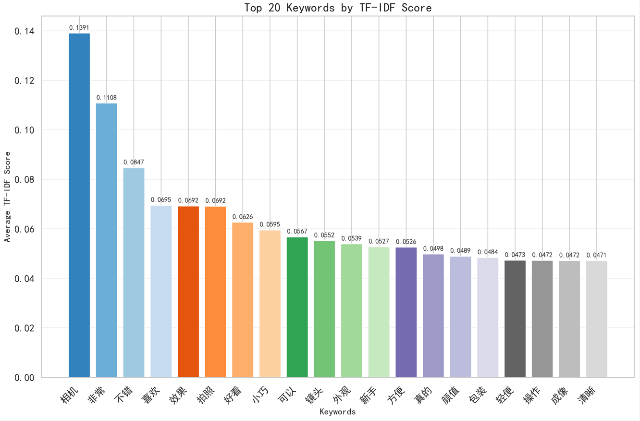
Heatmap
A heatmap of TF-IDF scores for the top keywords across the first 10 documents illustrates how keyword importance varies per individual review. Some documents show very high TF-IDF scores for specific keywords (e.g., 0.860, 1.000), highlighting reviews that are heavily defined by one or two salient terms.
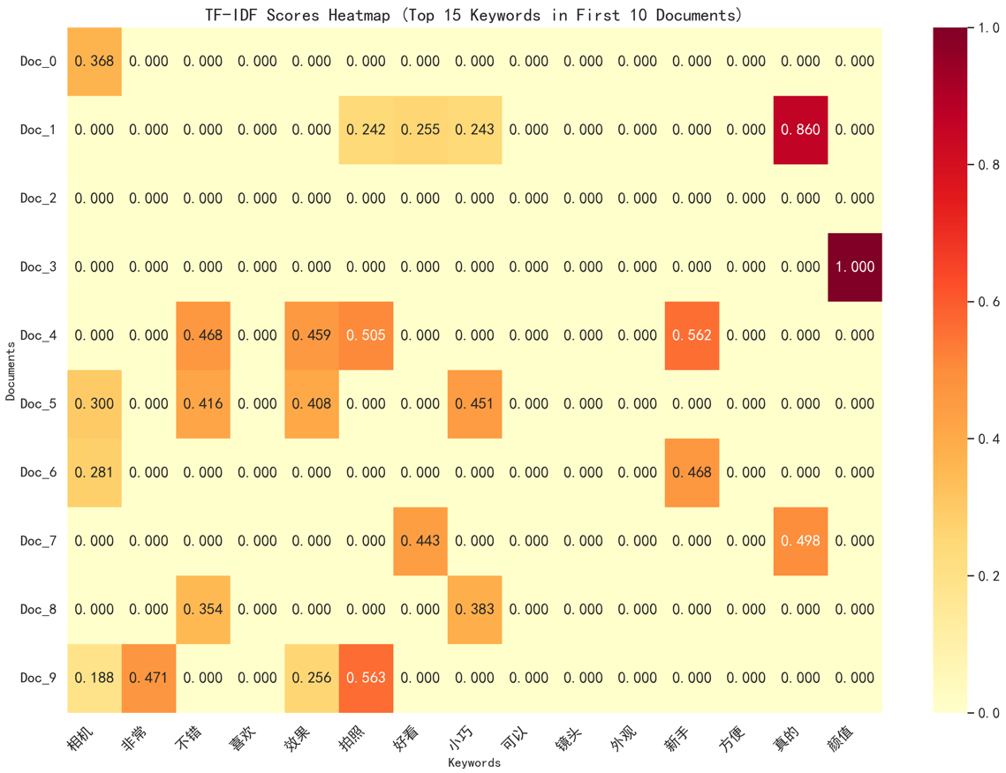
3.3 User Engagement Metrics
The classification and analysis output extended beyond sentiment to include the following engagement scores:
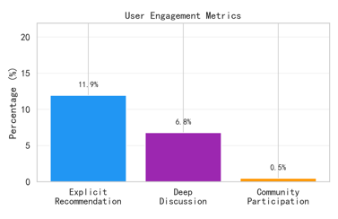

Report
2. Methodology
The methodology for this sentiment analysis project was designed to achieve the stated objectives systematically: determining sentiment distribution, comparing brand performance, identifying key discussion topics, and quantifying user engagement. The process integrated natural language processing (NLP) techniques, statistical aggregation, and metric derivation from user interaction data.
2.1. Data Preparation and Preprocessing
The raw text data, consisting of camera reviews and associated metadata (e.g., brand, user ID), was first cleaned and standardized. This involved removing irrelevant characters, normalizing text, and handling missing values. The text was then tokenized and prepared for input into the classification model.
2.2 Sentiment Classification and Distribution Analysis
To determine the overall sentiment distribution, a pre-trained transformer-based classification model (such as BERT or a comparable architecture fine-tuned for sentiment analysis) was applied. This model processed each review to assign a categorical label—Positive, Negative, or Neutral—along with a corresponding confidence score. The aggregate counts and percentages of these labels were calculated to produce the high-level sentiment distribution, revealing the dominant emotional tone across the entire dataset. The visualization of this distribution (e.g., a pie chart) clearly illustrated the overwhelming prevalence of positive sentiment.
2.3. Brand-Wise Sentiment Comparison
To compare performance across brands, the dataset was segmented by camera brand (e.g., Canon, Nikon, Sony, Fujifilm). For each brand segment, the average sentiment score was computed from the individual review confidence scores. This quantitative comparison allowed for a direct assessment of relative customer satisfaction levels. The results were visualized using a bar chart, highlighting both the consistently high positive sentiment across all major brands and the subtle variations between them.
2.4. Keyword Identification and Importance Analysis
To identify the most frequent and impactful keywords, a two-pronged analytical approach was used. First, simple term frequency was calculated to list the most commonly occurring words. Second, a Term Frequency-Inverse Document Frequency (TF-IDF) analysis was performed. TF-IDF evaluates the importance of a word not just by its frequency, but by how unique it is to a specific document within the corpus. This process highlighted keywords that were both common and distinctive to the discourse, such as "效果" (performance) and "小巧" (compact). The analysis was further refined by calculating separate TF-IDF scores for keywords found within positive-labeled reviews versus negative-labeled reviews, providing insight into the distinct vocabulary driving different sentiments. Results were presented via a top-N keywords chart and a comparative TF-IDF bar chart.
2.5. Derivation of Engagement Metrics
The Referral Score, Community Score, and Discussion Score were engineered metrics derived from parsing user engagement patterns within the conversation logs. The Referral Score quantified advocacy, potentially based on the detection of recommendation phrases or explicit sharing actions. The Community Score measured broader interactive participation, which could be calculated from metrics like the number of user posts, reactions received, or community badges. The Discussion Score gauged the depth of conversation threads, possibly derived from metrics like comment counts, reply chains, or thread lengths. These scores were calculated for each relevant user or review thread and then aggregated to produce the average scores presented in the dashboard. The distributions of these scores were analyzed to understand user behavior beyond pure sentiment.
3. Results
3.1 Brand-wise Sentiment Comparison
The sentiment classification model shows a dominant positive bias in the review dataset.The average sentiment scores for major camera brands (Canon, Fuji, Nikon, Sony) were calculated. All brands exhibit a very strong positive sentiment score, with neutral scores being significantly lower and negative scores being minimal. The variation between brands is slight, suggesting that overall customer satisfaction is consistently high across the market leaders analyzed.


Sentiment Scores Distribution (Left Chart):
This bar chart visualizes the distribution of sentiment scores across the dataset. The x-axis represents the sentiment "Score," ranging from 0.0 to 1.0, while the y-axis shows the "Frequency" of each score. The data is categorized by sentiment polarity, with blue bars representing "Positive" scores and green bars representing "Negative" scores. The most striking pattern is the extremely high and sharp peak of the green bar at the 0.0 score, indicating a significant concentration of reviews with the lowest possible negative sentiment score. In contrast, the distribution of positive scores (blue) is spread across higher values. The frequency of positive scores shows a rising trend from 0.0 to approximately 0.8, followed by a substantial concentration of data points in the 0.8 to 1.0 range, suggesting that positive sentiment is not only common but also tends to be strongly positive.
2. Referral Scores Distribution (Middle Chart):
This chart illustrates the distribution of referral scores using red bars. The x-axis denotes the "Score" from 0.0 to 0.4, and the y-axis shows the "Frequency," which reaches a much higher maximum (around 3500) compared to the first chart. The distribution is heavily skewed, characterized by a dominant, extremely tall peak at the 0.0 score. This reveals that the vast majority of entries have a referral score of zero or near-zero. A very small, secondary bump is visible around the 0.1 score, but the frequency drops precipitously for scores beyond that. The chart clearly demonstrates that high referral scores are exceptionally rare in this dataset.
3. Community vs. Discussion Scores (Right Chart):
This is a scatter plot exploring the relationship between Community Score (x-axis, 0.00 to 0.10) and Discussion Score (y-axis, 0.00 to 0.20). Data points are marked with purple dots. The points are not randomly scattered but appear to form loose clusters. One data point is isolated near the origin (0.00, 0.00). A vertical cluster of three points is located around a Community Score of 0.01, with their Discussion Scores spread between 0.00 and 0.20. Finally, two points are positioned in the upper-right quadrant, with higher Community Scores (approximately 0.09-0.10) and correspondingly higher Discussion Scores (0.10-0.20). This pattern may suggest a potential correlation or distinct groupings, where higher community engagement is associated with higher discussion activity for a small subset of the data.
Overall, the three charts employ a unified, clear visual style with distinct colors for easy differentiation. This side-by-side arrangement facilitates a direct comparison of the distribution characteristics for different key metrics derived from the analysis.
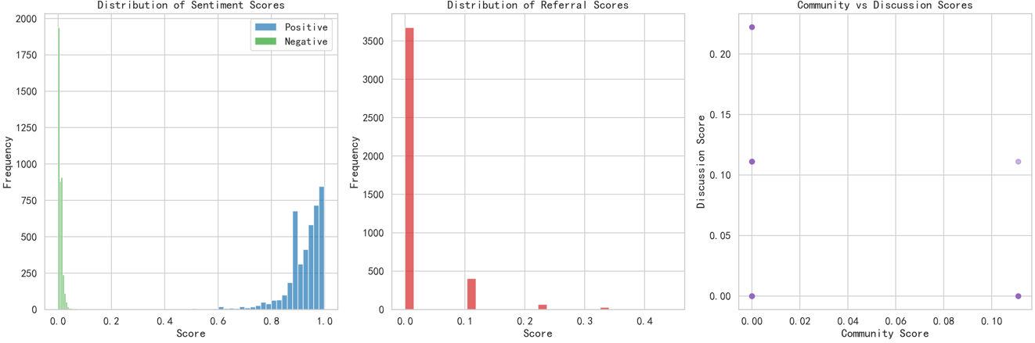
3.2 Keyword Analysis
Importance (TF-IDF):This chart is the definitive ranking of keyword importance for the entire dataset. It orders keywords by their average TF-IDF score, which balances frequency with distinctiveness. "相机" (camera) ranks highest with a score of 0.1391, solidifying its role as the central, most defining term. The sequence that follows—"非常" (very: 0.1108), "不错" (good: 0.0847), "喜欢" (like: 0.0695), "效果" (effect: 0.0692)—maps a clear narrative: the primary discourse is about liking the camera very much for its good performance. The presence of "拍照" (photography), "小巧" (compact), "轻便" (lightweight), and "外观" (appearance) in the top 20 confirms that the key drivers of positive sentiment and discussion are practical image-making capability, portability, and design. This chart effectively summarizes the "what" and "why" behind the overwhelmingly positive sentiment captured in the first dashboard.


Heatmap
This heatmap drills down to the level of individual reviews (Doc_0 to Doc_9), showing how keyword importance varies per document. It reveals the diversity of focus points among users. For instance, Doc_1 is highly defined by the keyword "镜头" (lens) with a score of 0.860, indicating a review focused intensely on lens performance. Doc_3 has an extreme focus on "颜值" (appearance/aesthetics) with a perfect score of 1.000. Other documents show a mix of moderate scores for several keywords. This visualization demonstrates that while the aggregate data shows common themes, individual reviews can be dominated by a single, salient feature that mattered most to that particular user. It adds granularity, showing that the overall positive sentiment is built from many specific, personally relevant praises.


3.3 User Engagement Metrics
The classification and analysis output extended beyond sentiment to include the following engagement scores:


